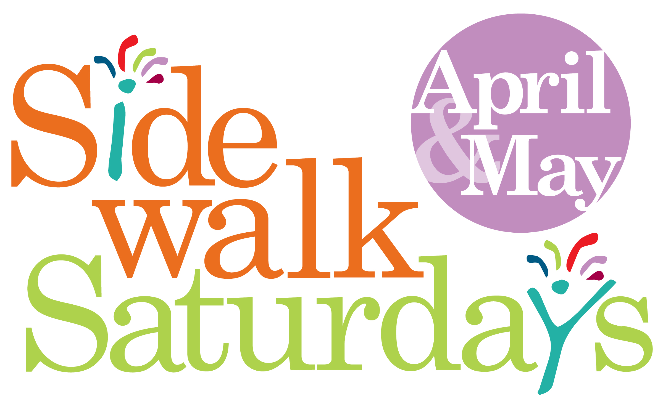
A pop-up
art program
with street performers, artists, poets, singers, musicians, dancers, and sidewalk chalk artists performing on key streets and corners in downtown Decatur and Oakhurst.
No need to pass the hat! Performers must audition and those selected will receive an hourly stipend.
Ready to take your
art to the streets of Decatur? To schedule
an audition contact sidewalksaturdayartists
@gmail.com.

OFFICE USE

Artist Application

Here’s how it works: Describe the audition process.
Please fill out this form and bring it to your audition.

NAME: ______________________________________________________________________________________
EMAIL: ______________________________________________________________________________________
STREET ADDRESS: ___________________________________________________________________________
CITY / STATE / ZIP CODE: ______________________________________________________________________
PHONE: _____________________________________________________________________________________
ARTIST TYPE:
VISUAL ARTIST MUSICIAN DANCER POET / SPOKEN WORD
STREET BAND OTHER STREET PERFORMER

BRIEFLY DESCRIBE YOUR WORK OR PERFORMANCE TYPE: ____________________________________________________________________________________________
____________________________________________________________________________________________
____________________________________________________________________________________________
____________________________________________________________________________________________
____________________________________________________________________________________________
____________________________________________________________________________________________
____________________________________________________________________________________________
____________________________________________________________________________________________
____________________________________________________________________________________________
____________________________________________________________________________________________

