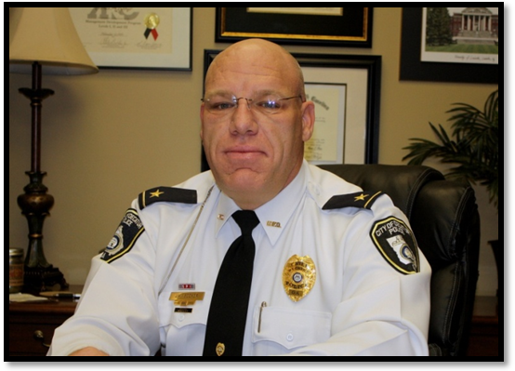
A MESSAGE FROM THE CHIEF
The City of Decatur Police Department is proud to present this Annual Report to the citizens, business owners, and visitors of Decatur. We believe by sharing this information with the public we will provide all who read this report with an accurate account of what transpired over the last year within the police department. We strongly believe without the trust and support of the community we cannot be as effective as we want to be. We continue to be a very open and transparent police department. We recognize without the trust and support of the community in our daily endeavors we will not be as successful as we have been. We also know that we could not have been this successful without the assistance and partnerships that we have formed within the community that we serve. We have long believed in the Community Oriented Philosophy of Policing. We will continue to be problem solvers and focus intently on providing a high level of service for the entire community. We want to continue addressing issues by providing professional, courteous, and quick responses to problems as they arise. Our department operates under a servant style of leadership which incorporates a “serve others before self” philosophy. We truly believe the way we treat people and the manner in which we do our jobs, along with the partnerships we have formed throughout our community is a powerful combination that yields outstanding results. We pride ourselves on being a professional law enforcement department and we hope we have shown that to all over the past year. We have continued to hire great people first and then trained them to become Decatur Police officers second. This accounts for a great deal of our success.
I feel extremely honored and privileged to serve as the Police Chief for the City of Decatur. The contents of this report are a credit to all the dedicated men and women of the Decatur Police Department who have worked extremely hard over the last year in their respective assignments. Their dedication and desire to succeed in this profession for the City of Decatur is shown in their work, as detailed within this report. We will continue to provide all with professional service, impeccable integrity, and a willingness to serve. Thanks for the continued support of your police department.

Sincerely,
J. M. Booker
Police Chief

Mission Statement
Our mission is to promote the quality of life in Decatur by providing police services with integrity and with a spirit of excellence, in cooperation with the community.

Statement of Values
We believe that our powers are derived from the people we serve.
We will not tolerate the abuse of police powers.
We recognize that our personal conduct, both on and off duty, is inseparable from the reputation of the department.
We are committed to protecting the rights of all individuals.
We believe our basic missions are to prevent crime and to deliver vigorous law enforcement services when crime occurs.
We believe in partnership with the community.
We strive to achieve our highest potential by actively involving our employees in problem solving and improving police services.
We support an organizational climate of trust and respect for one another.
We encourage the pursuit of higher education by our employees.
We are committed to the public we serve and to safety of all citizens of the City of Decatur.

Department Organization

J.M. Booker
Police Chief

E. Porter
Administrative
Assistant

Assistant

Task Force
(1)
Background Investigator
Communications
Lieutenant
J.B. Woodward
Investigators (4)

Animal
Control
Training
Lieutenant
M.J. Matics

A. Youngblood Administrative

Assistant
Communications
Officers
(11)

School Crossing Guards (21)
Evidence Technician

Support
Service Technician

SPU

Sergeant
Karolyi

Business
District Officers (2)

CID
Sergeant Ross

Team D
Sergeant
Beaupierre

Officers (4)

Team C
Sergeant
Clark

Officers (4)

Team B
Sergeant Woodruff
Officers (4)

Officers (4)

Team A
Sergeant
Canipe

Officers (4)

D.P. Hipple
Captain
CID/SPU

W.S. Richards
Captain
Patrol

J.K. Lee
Deputy Chief

J. Francis
Community Relations Specialist

K.L. Boyett
Captain
Support Services

Lieutenant

A.L. Sibley

Lieutenant

M.H. Hensel

Traffic Unit
Officers (2)
School Resource Officer

POP/DHA
Unit Officers (3)
Crime Rate

Background ISchool CTeam B
Sergeant
Woodruff

OffW.E. PortJ. GJ.K. Lee
Deputy Chief

uppLieutenant

A.L. Sibley

Animal

Team D
Sergeant

BeaupierrSchK.L. Boyett
Captain
Support Services
ontrol

Control
Training Evidence Technician
cs

E. Porter
Administrative
Assistant

J. Grooms
Community Relations Specialist

J.K. Lee
Deputy Chief

J.M. Booker
Police Chief
The current accepted measurement of criminal activity in the United States is measured by the Uniformed Crime Reporting (UCR) Program. The City of Decatur Police Department voluntarily participates in the traditional summary reporting system to the Federal Bureau of Investigation. The UCR Program assembles offense information, called Part I offenses for murder, forcible rape, robbery, aggravated assault, burglary, larceny-theft, motor vehicle theft, and arson. The UCR Program limits the reporting of offenses known to the eight selected crime classifications because they are the crimes most likely to be reported and most likely to occur with sufficient frequency to provide an adequate basis for comparison. Uniform Crime Reports collectively provide a national and local view of crime and allows administrators to identify trends in criminal activity and adopt suitable enforcement measures.

The finalized 2009 UCR for the City of Decatur showed an overall decrease in Part I offenses by 11%. A total of 954 Part I offenses were reported in 2009 compared to 1069 in 2008. Robberies decreased by 26%, Burglaries were down 16% and Larcenies/ Thefts were down by 16%. Four Rapes were reported in 2009 and all were marked as cleared.

The clearance rate is the percentage of crimes that are solved or cleared. A case can only be cleared by one of two ways: (1) the arrest of the offender or (2) by exceptional means. A clearance by exceptional means occurs when the offender is known but for some reason, no arrest is anticipated. Examples of clearances by exceptional means include: the victim refuses to prosecute, the death of the offender, or extradition of the suspect from another state has been denied. Most cases that are cleared by exceptional means stem from the victim’s refusal to prosecute. A case is not cleared by the recovery of stolen property. The closing of an active investigation does not clear a case. A case can only be cleared when an investigation has identified an offender, probable cause exists for the offender’s arrest, and the case is cleared by the arrest of the offender or by exceptional means.

In 2009, 27% of Decatur’s Part I Offenses were cleared as compared to 20% in 2008. Total crimes against persons showed a clearance rate of 76% in 2009 as compared to 62% in 2008. Total crime against property yielded a clearance rate of 16% in 2009 as compared to 12% in 2008. An increase in clearance within the categories of Robbery, Assaults, Burglary and Larceny Thefts all occurred during the 2009 reporting year.

The chart on page six depicts a Comparative Crime Analysis of Part I Offenses for 2009 versus 2008. The chart also shows the clearance rates for Part I Offenses for 2009 and 2008.

The first chart depicted on page seven, displays a visual historical comparison of Total Part I Crimes for the years of 2002-2009. The second chart depicted on page seven, displays a visual historical comparison of Total Crimes against Persons for the years of 2002-2009.

The first chart depicted on page eight, displays a visual historical comparison of Total Property Crimes for the years of 2002-2009. The second chart on page eight is a chart displaying motor vehicle accidents statistics to include total accidents, number of injury accidents, pedestrian involved accidents, fatality accidents as a result of driving under the influence and number of fatality accidents. Each category is divided into monthly columns for the entire year of 2009.

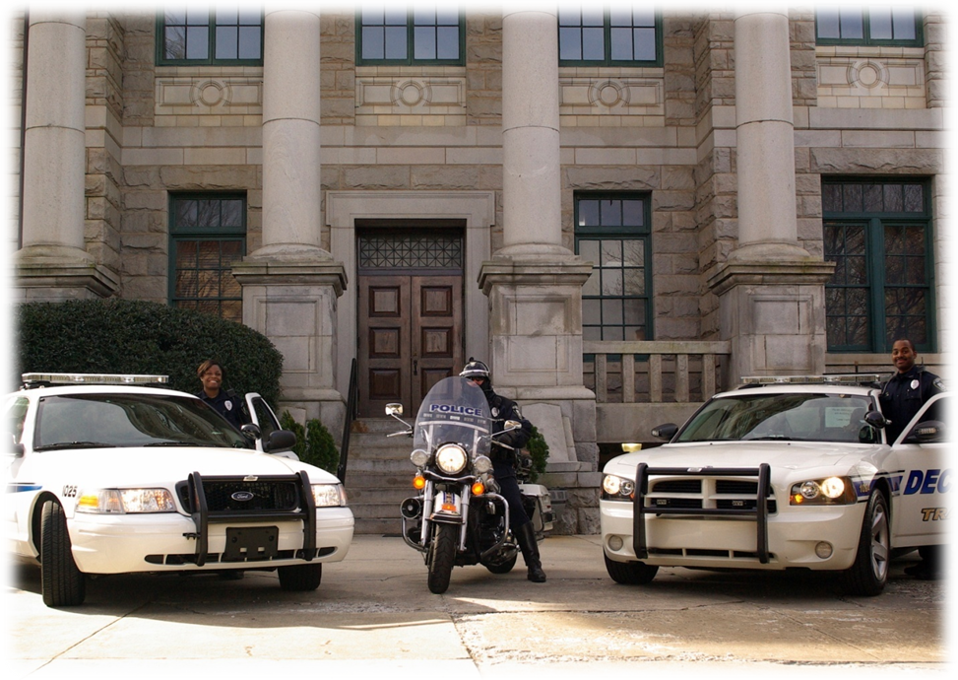

CITY OF DECATUR
POLICE DEPARTMENT
COMPARATIVE CRIME ANALYSIS

2009 COMPARED TO 2008

PART I OFFENSES
Offense | 08 INCIDENTS | 09 INCIDENTS | % +/- | 08 CLEARED | % CLEARED | 09 CLEARED | % CLEARED
HOMICIDE | 1 | 1 | 00% | 3 | 300% | 1 | 100%
RAPE | 1 | 4 | + 300% | 0 | 00% | 4 | 100%
ROBBERY | 35 | 26 | - 26% | 11 | 31% | 11 | 42%
ASSAULT  (aggravated/simple) | 133 | 151 | + 14% | 91 | 68% | 123 | 81%
BURGLARY | 201 | 168 | - 16% | 19 | 9% | 25 | 15%
LARCENY – THEFT | 629 | 529 | - 16% | 78 | 12% | 91 | 17%
MOTOR VEHICLE THEFT | 69 | 75 | + 9% | 10 | 14% | 7 | 9%
TOTAL | 1069 | 954 | - 11% | 212 | 20% | 262 | 27%
TOTAL CRIMES AGAINST PERSONS | 170 | 182 | + 7% | 105 | 62% | 139 | 76%
TOTAL CRIMES AGAINST PROPERTY | 899 | 772 | - 14% | 107 | 12 % | 123 | 16 %

Accident Data
DATES | ACCIDENTS | INJURIES | ACCIDENT WITH  PEDESTRIAN | DRIVING UNDER THE  INFLUENCE  FATALITIES | FATALITIES
January 2009 | 36 | 7 | 1 | 0 | 0
February 2009 | 70 | 14 | 0 | 0 | 0
March 2009 | 67 | 9 | 1 | 0 | 0
April 2009 | 76 | 9 | 3 | 0 | 0
May 2009 | 70 | 15 | 3 | 0 | 0
June 2009 | 72 | 11 | 2 | 0 | 0
July 2009 | 56 | 6 | 0 | 0 | 0
August 2009 | 86 | 9 | 1 | 0 | 0
September 2009 | 57 | 7 | 0 | 0 | 0
October 2009 | 66 | 10 | 0 | 0 | 0
November 2009 | 57 | 10 | 0 | 0 | 0
December 2009 | 58 | 6 | 1 | 0 | 0
TOTALS | 771 | 113 | 12 | 0 | 0

Internal Performance Measures

The City of Decatur Police Department strives to provide the utmost professional service to its residents and community members who come into contact with the department on a daily basis. The department operates with transparency offered to the public in an effort to further strengthen the bonds and trust which are required to create a partnership within the community. To ensure professionalism directs the daily activities of the department, the City of Decatur Police Department utilizes several internal performance measures, intended to guarantee continued competent service to the community. Each officer within the department is given a copy of the department’s integrity requirements and must agree to conduct him/herself to the standards set forth within the statement. The statement summarizes character traits expected from within the agency and profession. Character traits such as personal honesty, integrity and impartiality are discussed within the document and are used to guide the daily actions of the officer within the capacity of his/her duties. Failure to meet the requirements at any time of employment is grounds for dismissal of employment from the City of Decatur Police Department.

To further provide quality service and monitor itself from within, the department utilizes a system of checks and balances centering around Internal Monitoring Software, Internal Affairs Trak or IA Trak, designed to assist first line supervisors as well as administrators in identifying improprieties which may be developing within the department. Built into the software is an early warning system which monitors entries for each member of the department and warns administrators of excessive indicators of certain categories. It is the policy and procedure of the Decatur Police Department to investigate all citizen complaints, incidents of officers’ use of force, pursuit and officer involved motor vehicle collisions.

The Decatur Police Department accepts all complaints from the community and conducts appropriate investigations to display its determination to provide quality service and continued desire to improve on its procedures. Although it is preferred that a complainant submit a written complaint, the absence of a written complaint does not relieve the department of its responsibility to thoroughly investigate all complaints received. Upon the reception of a citizen complaint, the first and second line supervisors conduct preliminary and fact finding investigations into the allegations and make referrals to administrators based on those findings.

Outcomes of investigations are then given designations to categorize the findings which are described below.

Sustained:
Evidence discovered during the investigation is sufficient to support the allegation. In most incidents this results in disciplinary action taken against the involved officer. In rare cases, this finding could result in a change in department policies or procedures or the implementation of new training procedures.

Not Sustained:
Insufficient evidence was discovered in the investigation to either prove or disprove the complainant’s allegation. In most incidents where a complaint in not sustained, it is because there are no independent witnesses to corroborate the allegation, no physical evidence, i.e., video recording of the incident and there are conflicting accounts of the incident. In the overwhelming majority of these incidents, the complaint concerns statements allegedly made by the officer.

Unfounded/Exonerated:
Evidence discovered during the investigation disproves the complainant’s allegations.

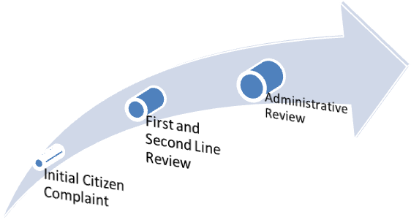

In 2009 the Decatur Police Department received 31 citizen complaints. During the investigation of one of these complaints, it was discovered the complaint involved another law enforcement agency, not the Decatur Police Department. The investigation was closed as Unfounded and forwarded to the appropriate agency. One of the complaints was filed by an anonymous complainant and did not identify the officer. The investigation was unable to determine the nature or content of the complaint. This complaint was closed as Unfounded. The remaining 29 complaints were investigated and reviewed by the department’s command staff. The following is a synopsis of the investigation findings:

Not Sustained: 4
Unfounded/Exonerated: 21
Sustained: 4

In each of the incidents where the allegations were sustained the officer received disciplinary action. These statistics are important because it illustrates the professionalism of the members of the department. Although members of the department made 1,123 arrests, conducted over 11,000 traffic stops and responded to over 18,000 calls for service, only 29 citizen complaints were received and of those only 4 were substantiated.

The nature of the interactions Decatur Police Officers often have with the public can change as police-public situations are fluid and/or the demeanor of the individual/s deteriorates. Often officers are forced to encourage members of the public to comply with lawful orders or are required to govern conditions to prevent situations from degenerating out of control. When this occurs, officers may have to use varying levels of force to encourage an appropriate outcome. Upon learning of any use of force, first and second level supervisors initiate fact-finding investigations into the actions of the officer. Upon completion of those initial inquiries, recommendations are forwarded to appropriate division commanders who then conduct reviews of policy and procedure and compare those with the officer’s actions. Appropriate action is then taken which can vary from justification of action to higher levels of reprimand. Most law enforcement agencies document use of force incidents, however there is no legal requirement to do so, nor is there a standard definition of what constitutes use of force. The City of Decatur Police Department has chosen to define use of force very broadly, and thus includes many incidents which most other departments would not. For example anytime a City of Decatur Police Officer draws their service weapon and points it at a suspect, a use of force report must be submitted and reviewed. Most agencies only consider this a use of force if the weapon is fired. The Decatur Police Department classifies all incidents where physical force is used to restrain a suspect as a use of force.

The following use of force statistics were compiled for the year 2009:

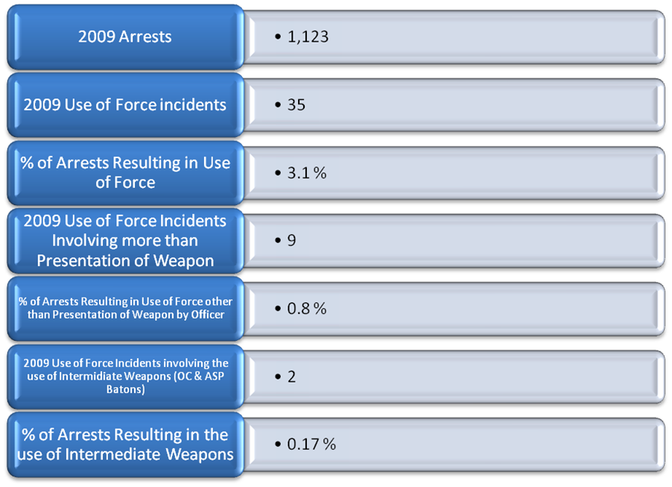

It is the policy of the Decatur Police Department to ensure the safety of the public, exercising great restraint when appropriate. A growing level of sensitivity within the policing community occurs with respect to motor vehicle pursuits. It is the policy of the Decatur Police Department to not engage in motor vehicle pursuits unless certain criteria are met. The department leadership recognizes the inherent danger to both participants and uninvolved motorists in motor vehicle pursuits. Upon initiation of a pursuit, a supervisor must immediately review all known facts of the interaction with the offender. He/she then must make the immediate determination if the pursuit is supported or not by department operating procedure. If the pursuit does not meet the strict requirements set forth, the pursuit is terminated. Review of the initiation of the pursuit is then conducted by first and second line supervisors and facts are forwarded to the division commander. In 2009, officers of the Decatur Police Department participated in only 2 motor vehicle pursuits. In both pursuits, the initiating officer terminated the pursuit prior to the violator stopping. No accidents were involved in either pursuit and no injuries occurred.

To continue to develop lines of communication with the residents of the City of Decatur, supervisors conduct monthly quality of service checks with complainants and victims of crime. The checks are conducted in person or over the phone and solicit feedback from individuals concerning their personal interactions with department officers. Results are documented and filed to monitor officer behavior and assure proper procedure is adhered to for any level of service provided.

The City of Decatur Police Department remains committed to its goal of “Enforcing a Higher Standard.” The above performance measures are a testament to the quality individuals who served the City of Decatur as Police Officers during the 2009 year.

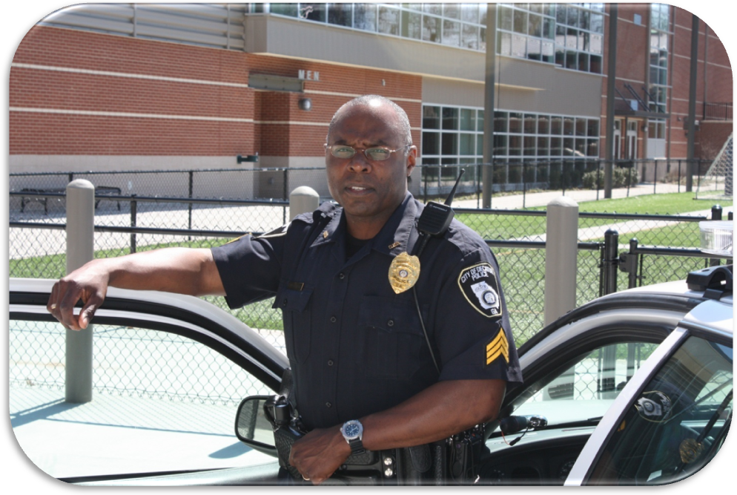

Uniform Patrol

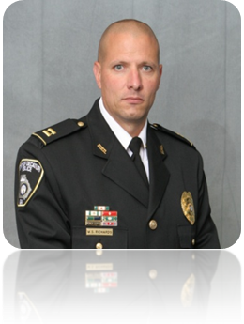
Captain W. S. Richards

The Uniform Patrol Division, led by Captain W.S. Richards, is responsible for the daily protection of residents and visitors. The majority of incidents and request for service into the Decatur Police Department are handled by the Uniform Patrol division. The patrol division is the largest unit within the Decatur Police Department and is comprised of 28 sworn officers assigned to the division. The officers are divided up among four patrol shifts given an alpha numeric designation. The patrol teams Alpha, Bravo, Charlie and Delta each work 12-hour shifts running 7 a.m.-7 p.m. or 7 p.m.-7 a.m. The teams rotate from days to nights and back every four months. Each team is supervised by a Sergeant who reports to a Lieutenant. The remainder of the shifts are made up of four or five Police Officers and Master Police Officers. The actions and services performed by the members of the Uniform Division are also the most recognizable, visible and scrutinized within the agency. Patrol officers enforce traffic and other criminal laws while patrolling the city. In addition they are the first responders for various incidents occurring within the city, conduct preliminary investigations and develop positive community relations. Over time, they learn what areas of law enforcement they are most interested in and focus on those areas. Some may choose drug enforcement while others look toward traffic enforcement or DUI, for example. Patrol officers who show an interest and aptitude in these specialty areas can apply for reassignment to Specialized Units when positions become available.

During the 2009 year, patrol officers responded to 18,164 calls for police related services. As a result of those calls for service and self-initiated activity, 4190 reports were generated in association with 51,755 self-initiated incidents investigated. The average response time for a police officer to respond to a call for service in 2009 was 4 minutes or less. The Uniform Division in combination with the Traffic Safety Unit and Criminal Investigation Division affected the arrest of 1,123 individuals, with Uniform Patrol conducting most. During 2009, Patrol Officers initiated 60 driving under the influence arrests and 146 VGCSA (Violation of Georgia Controlled Substance Act) arrests. As a result of calls for service and self-initiated activity, 7,833 citations were issued during 2009. Of those, 2,754 were issued for speeding in excess of maximum limits. Uniform Patrol also responded to 771 accidents which occurred within the city limits. During 2009, Uniform Patrol also assisted in implementing the False Alarm Program in order to address the re-occurring problem of false alarms reported to the Decatur Communications Division.

Traffic Safety Unit

In 2009 to address the growing area of Traffic Safety, the Decatur Police Department implemented its traffic safety initiative which comprised of two officers being re-assigned to a newly formed traffic unit. The focus of the traffic safety unit is to emphasize the importance of keeping city roadways safe and orderly. The goal is to reduce the number of traffic accidents injuries and deaths while promoting safety through enforcement, visibility and education. To do this traffic safety officers focus on speed reduction, high risk driving behavior, DUI patrol and pedestrian traffic safety. In 2009, officers utilized two specifically marked vehicles which identified themselves as traffic officers, a 2009 Dodge Charger and 2009 Harley Davidson Road King Motorcycle. In 2009, the two officers assigned to the traffic safety unit issued a total of 4,402 citations for various traffic infractions related to the motor vehicle code. The majority of infractions witnessed and cited for were the violation of controlled speed throughout the city. As a result a total of 2,332 citations were issued for that specific offense. The officers assigned to the traffic unit receive additional training in their specialized area and respond to specific areas of concern which have been identified by police administration. The traffic safety unit focuses heavily on the school zone speed limit enforcement throughout the city in an attempt to promote a safe environment for juvenile pedestrians and their parents during designated times in the morning and afternoon. During 2009, a total of 724 citations were issued in school zones by the traffic safety unit. In addition, traffic safety officers attempted to increase enforcement in the area of driving under the influence. In 2009 officers conducted 17 weekend saturation patrols to specifically target the offense of driving under the influence. Traffic safety officers also attend monthly MATEN (Metro Area Traffic Enforcement Network) meetings to stay current in trends which are changing within the traffic enforcement community. The network, which has been designated by the Governor’s Office of Highway Safety, is designed to enhance traffic enforcement activities through networking, training and legislative updates.

To further emphasize the Decatur Police Departments recognition of the importance of traffic enforcement, additional measures have been implemented to assist the traffic safety unit in enforcing traffic laws within the city. First, all uniform officers are required to receive training in the operation of laser speed detection devices for speed enforcement. Second, all officers are also required to receive training in Standardized Field Sobriety Tests to detect and arrest drivers suspected to be under the influence of alcohol or drugs. Third, patrol shift supervisors use safety checkpoints to detect unbuckled drivers and drivers who are under the influence of alcohol or drugs. Fourth, patrol supervisors assign officers to conduct speed enforcement inside school zones throughout the city of Decatur. Finally, officers are selected to participate in statewide traffic campaigns including Summer HEAT and Operation Click-It or Ticket within the City of Decatur.

Aside from traffic enforcement, the Decatur Police Department uses another resource to increase traffic safety. The department has a computer device, called a Stealth Stat, which can measure the speed of cars and record the number of cars traveling on a certain roadway. Once the Stealth Stat has completed its survey, the results can be printed out and evaluated. The survey results can be used by the Command staff to determine if more resources or directed patrols are needed for a particular roadway. The Stealth Stat also displays a visual speed, which is clearly visible to the driver, as it travels on a particular section of a roadway. The goal behind the visual depiction of speed is that drivers will see their speed and will modify their speed to stay within posted speed limit.

In 2009, the Decatur Police Department investigated 771 traffic accidents. These accidents included accidents involved on public roadways, accidents involved on private property, hit-and-run accidents, and accidents involving pedestrians. The following chart depicts the number and types of accidents investigated in 2009.

DATES | ACCIDENTS | INJURIES | ACCIDENT WITH  PEDESTRIAN | DRIVING UNDER THE  INFLUENCE  FATALITIES | FATALITIES
January 2009 | 36 | 7 | 1 | 0 | 0
February 2009 | 70 | 14 | 0 | 0 | 0
March 2009 | 67 | 9 | 1 | 0 | 0
April 2009 | 76 | 9 | 3 | 0 | 0
May 2009 | 70 | 15 | 3 | 0 | 0
June 2009 | 72 | 11 | 2 | 0 | 0
July 2009 | 56 | 6 | 0 | 0 | 0
August 2009 | 86 | 9 | 1 | 0 | 0
September 2009 | 57 | 7 | 0 | 0 | 0
October 2009 | 66 | 10 | 0 | 0 | 0
November 2009 | 57 | 10 | 0 | 0 | 0
December 2009 | 58 | 6 | 1 | 0 | 0
TOTALS | 771 | 113 | 12 | 0 | 0

Criminal Investigation & Specialized Patrol Unit Division

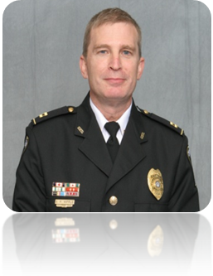
Captain D.P. Hipple

The Decatur Police Department has one specialized division of investigators. The investigators are selected from the patrol division after learning basic police investigative techniques and responses to crimes. After doing so, they are allowed to apply for a position within the Investigations Unit once a position becomes available. Upon transferring into the Investigation Division, these officers are charged with investigating and solving all crimes against persons and property. The investigators work Monday through Friday but are on call for investigations twenty-four hours a day, seven days a week. The staff is trained in modern methods of investigation in areas including white-collar crimes, juvenile crimes, identity theft, homicide and crimes against property and persons.
Four criminal investigators make up the Criminal Investigation Division (CID). The investigators are responsible for investigating crimes occurring within the City and performing background checks on Public Safety Department employment applicants. Every reported crime generated within the City of Decatur is reviewed to determine its level of solvability and then assigned to an appropriate investigator. All have received advanced training in various levels of specialty. In addition, one investigator is assigned to maintain the property room where all evidence and items are held for safekeeping and stored.
During the 2009 calendar year, Decatur CID investigated / assigned 1135 crimes which occurred within the city. Of those, 185 were resolved with the initiation of arrest warrants or other means. 719 were suspended for lack of leads or other investigatory reasoning. In 2009, CID had a 100% clearance rate for murders and rapes which had occurred. It should be noted; Decatur CID had an increase in clearance rates for 6 out of the seven UCR categories in 2009. CID uses a 30 day threshold to review cases in order to keep investigations current which assist in the likelihood an offender will be apprehended.

School Resource Officer

The City of Decatur Police Department had one officer assigned to the City of Decatur Schools in 2009 to ensure the safety of the students and faculty within the system. The officer works closely with the administration of all the schools within the Decatur School System and is a liaison for the department with the school. The officer has many responsibilities and often must wear many different “hats” as the environment they work in consists mainly of juvenile students. The officer first provides law enforcement and police services to the school, school grounds and areas adjacent to the school. The officer will investigate allegations of criminal incidents, enforce state and local laws and ordinances and make appropriate referrals to juvenile authorities or other governmental agencies. The officer also is a positive influence within the system and establishes a relationship throughout the school system in order to attempt to prevent and reduce instances of juvenile delinquency. The officer also works closely with school administrators to establish emergency crisis measures and address any security issues that may arise during the school year. The officer also works school events during after school hours which vary from sporting events to formal events and award presentations.

During the 2009 calendar year, 115 calls for service/incidents were generated within the school system. Investigations and activities sometimes resulted in the arrest of individuals from within the system. The Decatur SRO addressed a number of truancy issues which were handled in house by the school administrators or referred to an outside juvenile agency. During the 2009 calendar year, the SRO worked all school activities which occurred during after school hours and required police presence for crowd control and general public safety. Examples of this include the Varsity Football home games and Varsity Basketball home games.

During the 2009 year, the Decatur Police Department participated in the dual enrollment Criminal Justice Course taught at the Decatur High School. Courses taught by department personnel included:

* Community Policing and Relations with the Public
* Ethics and Legal Responsibility
* Information Technology and Applications
* Leadership
* Criminal Investigations Procedure
* NIMS & the Importance of the Command Structure

Communications / Support Services

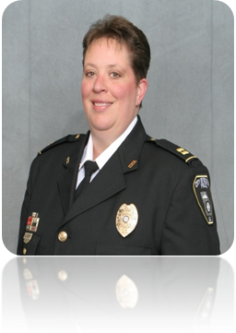
Captain K.L. Boyett

A fast and reliable communications division is vital to providing life saving services to the community it serves. Receiving and dispatching calls for service is the Decatur Police Department Communications Division’s main responsibility. The Communication Division employs state of the art equipment and is E-911 Phase 2 compliant. The ability to locate E-911 calls utilizing GIS, even if the call is coming from a cell-phone, saves time and insures that help will arrive quickly. All Decatur Police Department Communications Officers are state certified and have attended the basic Communications Officer Class at the Georgia Public Safety Training Center. The Communications Division employs 11 communications officers who work a combination of either 8 or 12 hour shift’s for continuous coverage. The City of Decatur Police Communications division is a 24-hour operation ensuring citizens who require service are given prompt attention despite the time of day. In addition to dispatching responsibilities for the Police Department, the Decatur Communications Division also dispatches all Decatur Fire Department related services as well as relays call information as it pertains to Dekalb EMS.

In 2009, Decatur Communication Officers received a total of 93,420 calls into the 911 / Communications Center. These calls varied from emergency 911 services to administrative calls. Communications Officers dispatched a total of 18,164 calls for service to officers in the field and generated a total of 51,755 incidents on their behalf. The average dispatch time of a call received by Communications Officer in 2009 was 1 minute or less.

During 2009, the Decatur Communications radio system was upgraded from analog to digital. This enabled the Police Department to have a wider ranging area of communication where commanding officers and police officers can also communicate with departments around the City of Decatur as well as expanding our own general communications capabilities. The upgrade includes expanded communication capabilities with the following agencies:

* Atlanta Police Department * Marta Police Department
* Emory University Police Department * Dekalb Police Department
* Dunwoody Police Department * Doraville Police Department
* Chamblee Police Department * Clarkston Police Department
* Stone Mountain Police Department * Lithonia Police Department
* Avondale Estates Police Department * Stone Mountain Park Police Department

This expands the ability to communicate with the listed agencies in a timely manner and relay information in disaster or mutual aid situations.

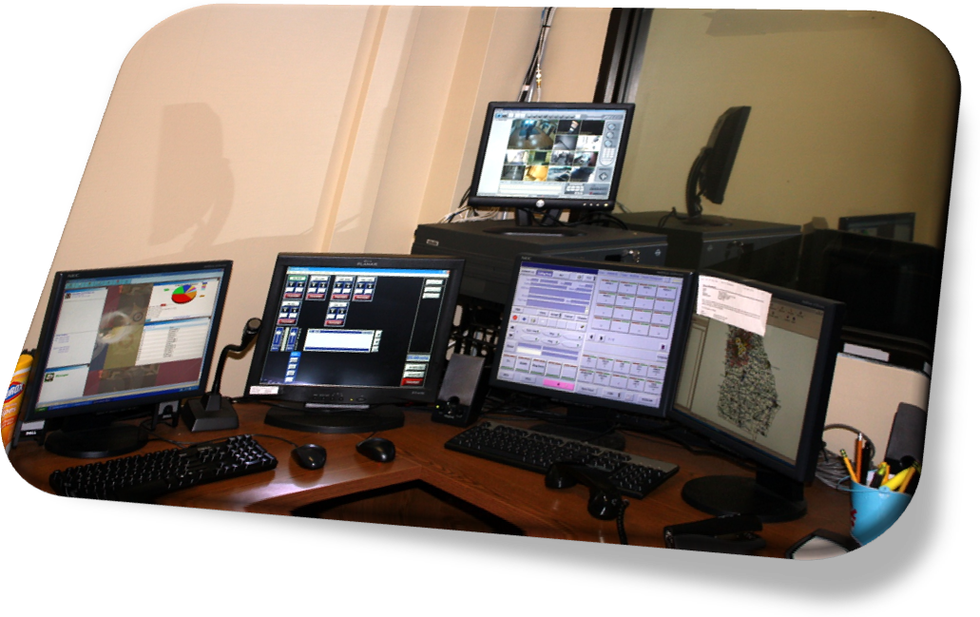
Animal Control

A number of calls for service into the communications division in 2009 were involving nuisance animals. The City of Decatur Police Department has one part-time Animal Control Officer who assists the department with the growing need to be able to enforce animal control laws and ordinances within the City of Decatur. In addition, the department works with Dekalb County Animal Control to provide adequate service to its residents, when the Decatur Animal Control Officer is off duty. The Animal Control Officers are also responsible for protecting citizens from wild, stray and aggressive animals. Officers respond to document instances of animal bites, stray animals, sick animals and requests to trap animals. Below is a chart indicating animal control statistics for 2009.

Animal Control Related Calls for Service 2009

Type of Call | Number of Incidents Investigated
Number of Dogs Running at Large | 240
Number of Animal Bite Reports | 4
Number of Barking Dog Complaints | 15
Number of Animals Returned To Owners | 3
Number of Wildlife Complaints  (Possums, Raccoons, Coyotes, Etc.) | 16
 | Dogs | Cats
Number of Dog/Cat Impounds | 5 | 10
Total (Including Cat Impounds) | 293

Community Policing Initiatives

The main foundation of philosophy in the Decatur Police Department in its attempts to curb crime within the City of Decatur is building a partnership with the community to more effectively allow the department to perform its function. To enhance the partnership, the Decatur Police Department utilizes and implements Community Policing Initiatives. Patrol supervisors ensure zone officers conduct daily Park-and-Walk patrols of their residential and commercial areas. The purpose of the Park-and-Walk patrols is to have the police officer park their patrol car and conduct foot patrols in different areas of their assigned zone. This allows officers to be visible in the community as a crime deterrent and makes them accessible to members of the community. Officers use Park-and-Walk patrols to discover the problems and issues firsthand by interacting with people from the community.

Juanchella Francis is the Decatur Police Department’s Community Relations Specialist. Ms. Francis acts as a liaison between the Decatur Police Department and the community. Members of the community are able to bring their problems and issues to Ms. Francis and she is able to refer them to the appropriate person or resource. In 2009, Ms. Francis expanded or continued a number of programs and initiatives which are designed to educate and promote a partnership with the community. Following is a list of programs participated in by Ms. Francis and the Decatur Police Department during the 2009 year:

- Neighborhood Watch Programs-activate and reactivate- Neighborhood Watch is a crime prevention program that employs the active cooperation of residents in united effort with law enforcement to reduce crime, solve problems, and improve the quality of life in an area.
- Conflict mediation - Mediated conflicts between/among young people and adults
- Christmas Decatur-A Season of Giving
- MLK, Jr. 3-Day Service Project
- Conducted crime prevention sessions for all sectors of the City of Decatur community that include: Decatur City Schools, Day Care and Pre-K Centers, Refugee Girls School, Church Groups, Women’s Groups, Senior Citizen Groups, retail establishments & Neighborhood Organizations
- Served as mystery reader at Decatur City Schools
- Serve as an advisory board member of the S.A.L.T. (Seniors and Law Enforcement Together) Council. This council’s goal is to educate senior citizens and offer programs, activities and methods for assisting them in areas of crime prevention.
- Decatur Housing Authority’s teen development program.
- Conducted security surveys.
- Serve as Advisory Board member of the Strategic Prevention Framework State Incentive Grant (SPF–SIG) program. This grant is a program of the Substance Abuse and Mental Health Services Administration (SAMSHA). During the next 3 years we will assess the following: 1. Preventing and reducing the rate of alcohol-related crashes and fatalities among youth and adults 2. Reducing the incidence of arrests among youth due to possession of alcohol products.
- Participated as a panelist in Decatur Housing Authority’s Parent and Teen Summit.
- National Night Out - National Night Out is a unique crime/drug prevention event sponsored by the National Association of Town Watch (NATW). This national event involves citizens, law enforcement agencies, civic groups, businesses, and neighborhood organizations from all over the country. National Night Out is designed to heighten crime and drug prevention awareness, generate support for, and participation in, local anticrime programs, to strengthen neighborhood spirit and police-community partnerships, and to send a message to criminals letting them know that neighborhoods are organized and fighting back. In August of 2009, the Decatur Police Department participated in National Night Out. Police officers at the rank of Lieutenant and above took to the streets by walking in neighborhoods throughout the city of Decatur to show and gather support for zero tolerance to crime.

Citizen’s Public Safety Academy

In 2009, the Decatur Police Department participated in the 18th Citizens Public Safety Academy. The students are citizens from the community who are interested in gaining a greater understanding of how public safety works in their community. Instructors, who are employees in public safety, are selected from different areas in public safety including police, fire, and communications. The students receive a general overview from instructors about a particular area relating to public safety. The program gives the students an opportunity to interact with members of public safety and to ask questions. One of the most important parts of the program is that citizens get to participate in a ride-along with police officers. This ride-along program gives students a new perspective on what a police officer does and what police work entails. After graduating from the academy, the students are able to take back what they learned to their communities, and in turn, the police department creates new relationships with citizens that we feel will be beneficial in the future.

Vacation Location Check Request

The City of Decatur Police Department offers the service to all residents within the city limits of the Decatur. This service allows a homeowner to contact the police department to notify them that there will be an absence at the residence and request periodic checks of the location. Uniform Officers are then made aware of the request and respond to the residence at multiple times to conduct location checks ensuring the residence is secure. In 2009 the Decatur Police Department offered the service to residents on-line via the City of Decatur website. This increased the ability of citizens to request the service. In 2009, the Decatur Police Department conducted 454 vacation residential checks throughout the city.

CAPS
Citizens Assisting Public Safety Volunteer Program
When Police Chief Booker was appointed to his position in June 2006, one of his first initiatives was to facilitate the creation of a volunteer program. Chief Booker received a telephone call from a graduate of a recent Citizen’s Public Safety Academy, asking how citizens could become more involved with assisting the police department. After more citizens began asking about volunteer opportunities within the police department, a wide range of activities were presented as possible roles for volunteers.

Chief Booker believes that the inclusion of citizen volunteers greatly assists the Police Department in serving the citizens of Decatur and furthers the partnership between the Police Department and its residents. Volunteers serve as additional “eyes and ears” in the community, enhancing the safety and quality of life in the City.

The program allows more informed citizens to participate in crime prevention and crime reduction efforts. This fosters a more proactive community neighborhood watch. The specific purpose of the program is to make the City of Decatur a safer community. The Department benefits from the added presence of volunteers dressed in identifiable clothing. The volunteers also help present a visible presence that will add in deterrence of possible crimes. The community benefits from the knowledge that other citizens are working to ensure their safety and that of our many visitors.

Recognizing that CAPS members are volunteers, public safety personnel endeavor to never place CAPS in harm’s way or in an uncomfortable position, but are utilized in a more appropriate capacity best suited for the citizen volunteer. CAPS members may serve in a variety of roles. Examples and summaries of some of the duties are listed below.

- Special Events – During special events the duties of CAPS members are focused on public safety functions. These duties might include the staffing of the Mobile Incident Command (MIC) unit, patrolling the event site and reporting hazards or suspicious activity, staffing crime prevention booths, operating barricades and controlling the flow of traffic through closed roadways, providing directions to motorists, etc.
- Business District Patrol – CAPS members also provide a presence on the downtown square, Oakhurst business district, and other commercial districts in Decatur. This greatly increases the visible public safety presence and creates an atmosphere of increased security when viewed along with the assigned business district Police Officer.
- Exam Proctoring – CAPS member have been asked to assist with proctoring promotion or proficiency exams or exercises.
- Role Play – CAPS member take part in role playing exercises that are part of officer training.
- Disaster Response – In case of a major weather or other event in the City, CAPS members may be called upon to assist with traffic control or provide other assistance to Police and/or Fire/Rescue personnel. CERT trained members might provide an additional level of support.

Training

Training has been and continues to an important area of focus for the Decatur Police Department for years and continued to be in 2009. The Chief of Police directs higher standards within the area of training and sees to that and requires officers to attend additional training above the required state level. The state of Georgia requires that each POST-certified police officer receive a minimum of twenty hours of training courses each year. In 2009 the Decatur Police Department took this a step further with each officer averaging 80 hours of training, well above the state mandated level. The Decatur Police Department completed 3,986 hours of training in 2009 for both police and communications personnel. It is believed that training is the cornerstone for the success of the organization. The Decatur Police Department tries to be proactive in its self imposed training requirements before the state legislature makes certain training areas required.

In 2009, all sworn personnel received in-service training relating to semi-annual firearms training, annual shotgun training, annual training for back-up weapons, use of deadly force, ASP baton, OC pepper spray, ethics, motor vehicle pursuits, and legal updates. Roll call training was completed by all patrol and CID personnel in reference to critical tasks. In addition, all sworn personnel received training by the Decatur Fire Department in CPR and AED. A guest speaker was brought in to teach the department an integrity in leadership course entitled, What Do They See When They See You Coming. The course was presented by Stephen Gower.

A representative of the Raksha and United for Safety group, which provides assistance to immigrants concerning family violence, came to the department and taught a Cultural Awareness course. These courses were made available to all members of the police department.

Georgia P.O.S.T. also put out a directive encouraging law enforcement agencies to create a policy and develop training in regards to Eye Witness Identification. The department created a new policy and then trained all sworn personnel prior to its adoption.

In 2009, we acquired several new pieces of equipment. Breaching tools and light-weight ballistic shields were purchased to help the agency better prepare for an active shooter scenario. All sworn personnel received training with the ballistic shield at the Dekalb County Firing Range. At least ten (10) officers have received training with the breaching tools and we will continue this training into 2010. It is the goals of the training unit to have all sworn personnel receive basic training in the use of breaching tools. Waist belts for front handcuffing and protective masks for prisoners who bite and spit were also acquired in 2009. Hands-on training was conducted for their use with all patrol and CID personnel. Shotgun training was expanded to include all sworn personnel. A combination of classroom and hands-on training was utilized to develop proficiency with the shotgun and each officer was able to qualify in their use at the Dekalb County Firing Range.

Specialized training was also given to officers to enhance their skills and provide better services to the community. Following is a list of those specialized courses:

* Domestic Violence * Latent Print Development
* Criminal Apprehension for Patrol * Laser Speed Detection
* INTOX 5000 Certification * Standardized Field Sobriety Tests
* Officer Survival * Leadership Skills Course
* Linguistic Statement Analysis * Supervision Training
*Tactical Breaching Techniques * Criminal Procedures
*Field Training Officer Course * Advanced Traffic Law
* Burglary / Robbery investigations * Criminal Drug Interdiction
* Street Gang Identification & Awareness * Verbal Judo
* Crime Analysis * Internal Affairs
* Intelligence Analysis * High Risk Warrant Service
* Response to Hazardous Materials Contingency * Motorcycle Operator Training
* Glock Armorer’s Course * Semi-Auto Pistol Level II
* Managing Multiple Priorities * Child Abduction Response Team
* On-Scene Accident Investigation Level One * NIMS Certified All-Hazards Type III
*All Hazards Council Seminar

In the above list the underscored course of “Supervision Training” was a developmental course produced by the Decatur Police Department for newly promoted supervisors within the agency. Newly promoted supervisors were required to attend the 40 hour supervision course which acclimated them to their new responsibilities. The class was taught by members of the Command Staff as well as four Lieutenants. Each member taught a block of instruction on the following topics:

* Leadership Skills * Case Management
* Shift Preparation / Duties * Staffing Issues
* General Forms * Employee Performance
* Internal Investigations * IA Trak
* Communications & the Role of Sergeant * Use of Force Investigations
* Training Roll of Sergeant

The Communications Division also received its share of training in 2009. Two Communications officers were selected to become Communication Training Officers. Those two both completed an in-service course and additional training at the “Institute of Police Management and Technology” in Jacksonville, Florida. In addition, four communications officers attended specialized training in Active Shooter Response.

Recruitment and Hiring
In 2009, the Decatur Police Department looked to improve upon the way it recruits and hires new police officer candidates. Traditionally, the department had solely relied on word of mouth or the utilization of the city wide web page to provide hiring and recruiting information to interested candidates. It was determined that those efforts were not meeting the rising expectations of the department and its need to have an adequate applicant. Therefore, an open bidding process was initiated to allow outside marketing firms to approach the Police Department with new and improved ways of recruiting new members of the department. The Decatur Police Department revolved its decision around which company would give the department individual attention in the requested area and work to build up the brand of recognition the department wished to sell. After accepting and reviewing offers, the department entered into contract with TEDCO International to employ new enlisting methods. TEDCO was believed to have the best fit for the department’s needs based on their vision and history in specialized marketing campaigns.

TEDCO initiated the expanded marketing campaign by identifying various media outlets which would provide maximum exposure of the agency toward the desired candidates and further relay the Department’s hiring goals to an appropriate audience. Several areas of the media were identified to include lawenforcement.com and policeone.com on the internet as well as “American Police Beat” in print. In addition, TEDCO created a micro site which again, broadcasted the agency’s needs and desires in such a manner which would solicit the best applicant possible.

Understanding those communities and the agencies that serve them all have different needs, TEDCO then met with all officers of the Decatur Police Department to establish commonalities which could be found amongst the members. The responses allowed TEDCO to appropriately identify the qualities they would be attempting to solicit from applicants and classify the desired characteristics required to perform the services required by the department to achieve its mission statement.

The program was deemed successful for the 2009 calendar year by increasing the candidate pool and allowing the department to select 7 officers during the year. The improved professionalism within the department and its desire to improve on all facets of its services also helped attract two previous members of the Police Department. Officers Shirley Kersey and Michael Mitchell both returned to service with the Decatur Police Department after an extended period of employment in other areas of law enforcement.

Promotional Process

In 2009 the Decatur Police Department initiated a promotional process to fill the need of first line supervisors within the agency. In the past, the process was conducted internally with very little oversight from a neutral body indifferent to the outcome of the process. To attempt to bring respect and credit back to the process, it was determined the Decatur Police Department would use an outside agency to conduct the promotional examinations for the positions of Lieutenant and Sergeant. The decision to utilize the services of Morris & McDaniel, Inc. was made. The group is recognized as a national leader in the area of personnel selection, organizational development, human resource consulting and personnel placement. Morris & McDaniel, Inc. provided customized exams for the ranks listed above and centered on selected reading text to include the City of Decatur Personnel Policy and Procedures Manual as well as the Police Department’s Policy Manual. Candidates for either rank participated in a Video Based Assessment Center. This performance-based assessment included dimensions such as Problem Identification and Analysis, Decision-making, Interpersonal Skills, Planning and Organization, and Oral Communications. All categories presented various scenarios applicable to the responsibilities of each rank. The candidates then were presented with a scenario and had a set period of time to develop and present their responses as to how they would handle the situation. The responses were videotaped and reviewed and scored by assessors brought in by Morris & McDaniel.

Candidates selected for promotion in 2009 were as follows:

* Lieutenant M. Hensel / employed September 1999

* Sergeant D. Canipe / employed July 1996

* Sergeant T. Karolyi / employed March 1997

* Sergeant J. Ross / employed June 1996

* Sergeant W. Woodruff / employed January 2003

Awards and other Noteworthy Activity

On December 12, 2009 the Police Department had its annual Christmas/Awards Banquet. The following awards were presented to the listed recipients:

* Manager of the Year: Sergeant C. Clark

* Officer of the Year: Officer A. Copeland

* Civilian of the Year: Brent Parrott

In 2009, Chief M. Booker was selected to the CRLEA Advisory Board. The board was formed as an advisory committee to guide the actions of the Clayton Regional Law Enforcement Academy.

Officer Candidate Nembheard graduated the Clayton Regional Law Enforcement Academy on October 8th, 2009. Upon doing so he was awarded the Clayton Regional Law Enforcement Academy Academic Award which distinguished him as having the highest Academic Average amongst classmates at 92.8 %.

Lieutenant Sibley, Sergeant Canipe, Officer Fiksman and Officer Batchelder participated in the “National Police Unity Tour” in 2009. The unity tour is a 300 mile bicycle ride designed to raise awareness for officers who have fallen in the line of duty and raise money for the National Law Enforcement Officer’s Memorial and Museum. Officer Batchelder rode in memory of Deputy Ann Jackson at the request of Officer Jackson’s family, who fell in the line of duty on Tuesday September 2, 2008 as a result of gunfire. Deputy Jackson was a 6 year veteran of the Skagit County Sheriff’s Department in Washington State.

